Consulting Solutions SQL CLASS SETUP
(using the USB thumb drive)
Updated April 29, 2016

Contents
Contents 1
1. Copy Files from USB(CD) to your Hard Drive 2
2. Install Oracle Database (Windows XP, 7, 8, 8.1, 10) (If you are running Windows Vista please go to Step No. 3 below first) 3
3. Install Oracle Database (Windows Vista) 3
4. SQL Developer Setup 4
5. Create System Connection in SQL Developer 5
6. Create Two Users in Database using SQL Developer 6
7. Create books Connection to Database in SQL Developer 7
8. Create cruises Connection to Database in SQL Developer 8
9. Load books tables 9
10. Load cruises tables (there are two files) 10
11. Installing Class Environment on Macbook Pro (El Capitan) 12
12. Some Useful SQL Links 12
13. Restarting Oracle 13
14. Resetting the Password for SQL Users 14

Copy Files from USB(CD) to your Hard Drive
You will either receive the class files on a pre-loaded USB key or may find them on DropBox at SQL Software > Oracleclass > setup
- Confirm you have the following files on your hard drive:
  - OracleXE112_WinZip32.zip
  - sqldeveloper-3.2.10.09.57.zip
  - BookStore.sql
  - Create_EFCodd_Version_X_Script_01.sql
  - Create_EFCodd_Version_X_Script_02.sql
  - Note1: You may also have a free version of WinZip on the thumb drive. There are two files on the thumb drive that require unzipping (extracting). See where to unzip in the instructions below. Your computer may have this already, in which case you will not need to use this file and will not need to copy it to your hard drive. If you do not know how to use WinZip please visit their website http://kb.winzip.com/kb/ for instructions or search Google.
  - Note2: If you do not see the file extensions on the files above and want to turn that feature on please visit: http://windows.microsoft.com/en-US/windows-vista/show-or-hide-file-name-extensions to learn how or search Google.

- Create directory C:\oracleclass on your hard drive
- Copy file OracleXE112_WinZip32.zip from USB to c:\oracleclass
- Copy file sqldeveloper-3.2.10.09.57.zip from USB to c:\oracleclass
- Copy following three files from USB to c:\oracleclass
  - BookStore.sql
  - Create_EFCodd_Version_X_Script_01.sql
  - Create_EFCodd_Version_X_Script_02.sql

Install Oracle Database (Windows XP, 7, 8, 8.1, 10)
If you are running Windows Vista please skip 1-11 and go to No. 3 Vista below
- Unzip (extract) c:\oracleclass\OracleXE112_WinZip32.zip into c:\oracleclass\OracleXE112_WinZip32\
- Create folder c:\oraclexe on your hard drive
- Browse to find c:\oracleclass\OracleXE112_WinZip32\Disk1\Setup.exe
- Right-Click on Setup.exe
- Choose Run as Administrator
- Confirm it is installing into C:\oraclexe
- IMPORTANT: WHEN PROMPTED FOR A PASSWORD ENTER> admin
During installation two error message dialog boxes similar to one shown here will pop up:
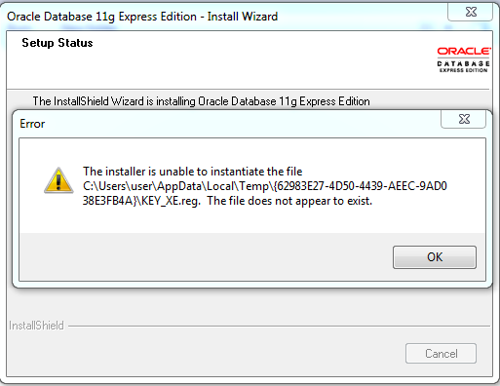
These two messages are expected and do not impact the program running.
Just click OK for both messages.

- After it completes the installation Reboot your PC
- Find icon on desktop: Get Started with Oracle 11g Express Edition > Click to launch
- Browser will start and desired outcome shown here: NOTE Chrome does not work in this step but Internet Explorer and Firefox do.

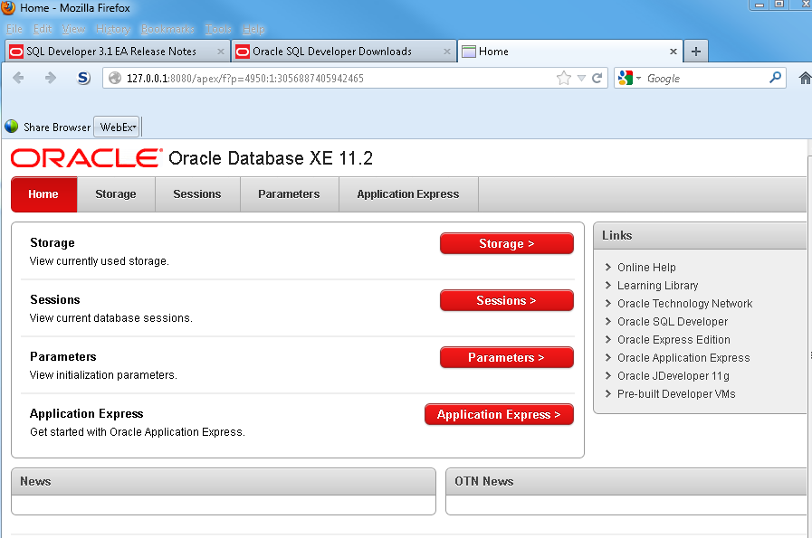

- Close browser

Install Oracle Database (Windows Vista)
If you are not running Windows Vista skip this step.
- Turn of wireless access
- Turn off firewall
- Turn off your virus protection
- Follow Step Nos. 1-11 above

SQL Developer Setup
- Unzip (extract) c:\oracleclass\sqldeveloper-3.2.10.09.57.zip into c:\oracleclass\sqldeveloper-3.2.10.09.57\
- Browse to c:\oracleclass\sqldeveloper-3.2.10.09.57\sqldeveloper\sqldeveloper.exe
- Launch sqldeveloper.exe
- Desired outcome shown below
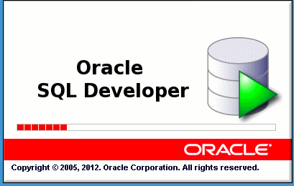

Create System Connection in SQL Developer
- Open SQL Developer
- Click on the Green Plus sign top left
- Create the connection for system
  - Connection Name: System
  - Username: System
  - Password: admin

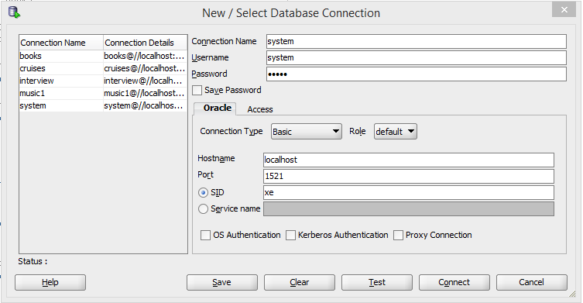

- Click Test
- Confirm Status: Success
- Click Connect

Create Two Users in Database using SQL Developer
- You are now in SQL Developer
- Make sure that System is showing in the top right
- NOTE: The screenshot below shows books. You may use books or books. Same for cruises.
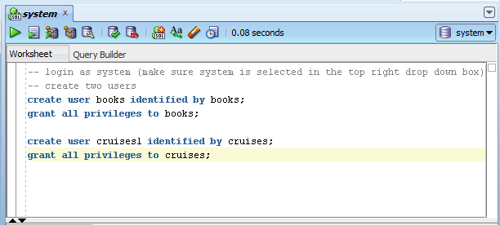

- Type in the commands you see here
- At the end of each line make sure you have a semi-colon
- Click Ctrl-Enter to execute each line

Create books Connection to Database in SQL Developer
Connection 1: books
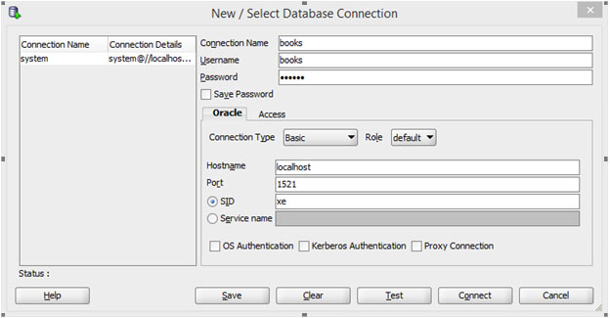

- Open SQL Developer
- Click on the Green Plus sign top left
- Create the connection for books
  - Connection Name: books
  - Username: books
  - Password: books
- Click Test
- Confirm Status: Success
- Click Connect

Create cruises Connection to Database in SQL Developer
Connection 2: cruises
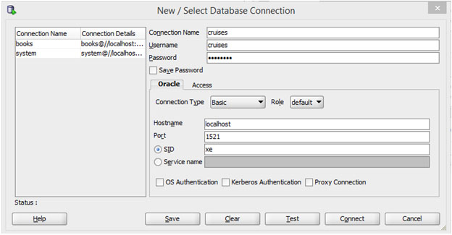
- Open SQL Developer
- Click on the Green Plus sign top left
- Create the connection for books
  - Connection Name: cruises
  - Username: cruises
  - Password: cruises
- Click Test
- Confirm Status: Success
- Click Connect

Load books tables
- Open SQL Developer
- File>Open>bookstore.sql
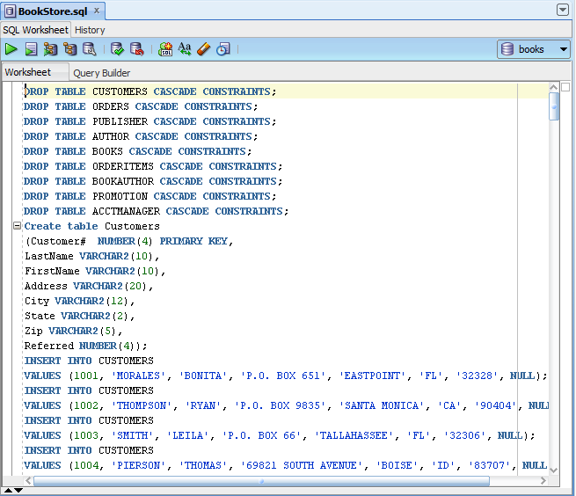
- Make sure books is selected in top right drop down
- Click your cursor in the window above with all the SQL commands
- Click CTRL-a (to select all)
- Click CTRL-Enter (to execute all the commands)
- In the left hand window click on the plus sign next to books
- Then click on the plus sign next to tables
- Confirm you have about 8 tables

Load cruises tables (there are two files)

File 1: Create_EFCodd_Version_X_Script_01.sql
- Open SQL Developer
- File>Open> Create_EFCodd_Version_X_Script_01.sql
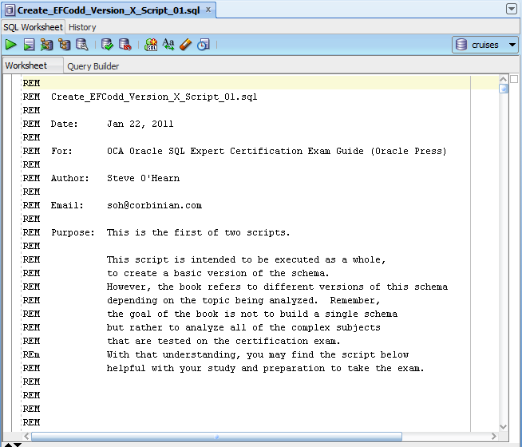
- Make sure cruises is selected in top right drop down
- Click your cursor in the window above with all the SQL commands
- Click CTRL-a (to select all)
- Click CTRL-Enter (to execute all the commands)
- In the left hand window click on the plus sign next to cruises
- Then click on the plus sign next to tables
- Confirm you have about 15-20 tables

File 2: Create_EFCodd_Version_X_Script_02.sql
- Open SQL Developer
- File>Open> Create_EFCodd_Version_X_Script_02.sql
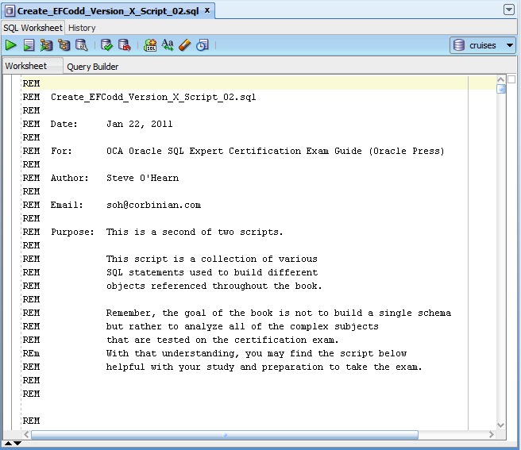
- Make sure cruises is selected in top right drop down
- Click your cursor in the window above with all the SQL commands
- Click CTRL-a (to select all)
- Click CTRL-Enter (to execute all the commands)
- In the left hand window click on the plus sign next to cruises
- Then click on the plus sign next to tables
- Confirm you have about 35 tables

Installing Class Environment on Macbook Pro (El Capitan)
Oracle does not make an Oracle Server for the Mac. The classroom Oracle environment called Oracle 11g Application contains both an Oracle client and server. If you are running Windows applications on your Mac already just open your windows environment on your Mac and use the installation instructions above. Although the VMWare products (that cost) are appreciably easier to work with, VirtualBox is free. Instructions below describe how to download and install VirtualBox, then use it to open a previously configured vbox instance called sqlcsn.
- Download VirtualBox > VirtualBox 5.0.20 for OS X hosts amd64
  - VirtualBox-5.0.20-106931-OSX.dmg
- Install VirtualBox on Mac
  - Double click on VirtualBox-5.0.20-106931-OSX.dmg
  - Double click on VirtualBox.pkg
  - Open from Applications Folder
- Copy csnsql.tar.bz2 to ~/VirtualBoxVMs/
- Copy VBOX User Manual.pdf to ~/VirtualBoxVMs/
- Untar ~/VirtualBoxVMs/tar -jxvf csnsql.tar.bz2
- Launch Finder > Browse to ~/VirtualBoxVMs/ > sqlscn
  - Confirm you can see sqlscn.vbox in finder
- Launch VirtualBox
  - See: Welcome to VirtualBox
- Double click file: sqlscn.vbox in Finder
  - Confirm you can see sqlscn in left window of VirtualBox
- Start sqlscn
  - Password: CSNPassword

Some Useful SQL Links
The last two I do not know much about but the first three I use regularly.
- TechOnTheNet:
http://www.techonthenet.com/
- Don Burleson’s site:
http://www.dba-oracle.com
- Tom’s site:
http://asktom.oracle.com
- PSOUG:
http://www.psoug.org/
- Online SQL course support materials:
www.sqlcourse.com/
- SQL Practice Site
https://en.m.wikibooks.org/wiki/SQL_Exercises/

Restarting Oracle
Occasionally Oracle will be shut off by some other activity on your computer. Not often but it is good to know how to get it restarted if this occasion visits you. When you installed Oracle there were 4 icons it placed somewhere on your desktop, start menu, or all programs menu. You will need to find those on your system. Once you find them. Follow these steps.
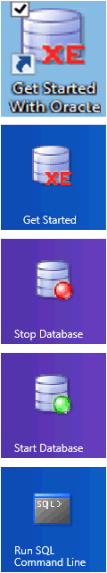
STEPS TO RESTART ORACLE
- Confirm Oracle is not working by clicking on Get Started or Get Started With Oracle. See Section 3 Install Oracle Database (Windows XP, 7, 8, 8.1) Step Nos. 9 and 10
- Click Stop Database (let it finish)
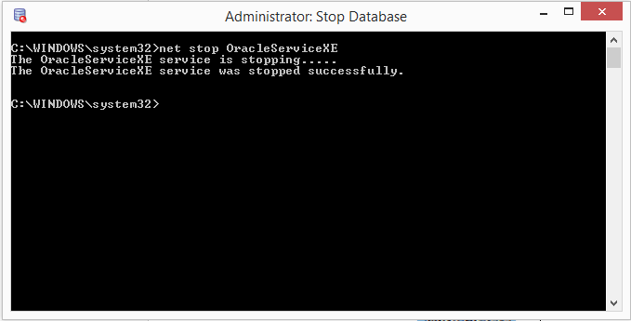
- Click Start Database (let it finish)
- Repeat Step 1
- If it still does not start, Reboot
- If it still does not start, uninstall Oracle using the technique for your Windows version, reinstall Oracle.

- Getting Started with Oracle

- Get Started

- Stop Database

- Start Database

- Run SQL Command Line

Resetting the Password for SQL Users
When Oracle is initially installed it sets a timeout period of 180 days (6 months) for passwords. There are primarily four users used through the course which depend on a valid password:
- system
- books
- cruises
- student_name (e.g. billy, audra, michael, britanney)
- Resetting system’s password.
Once you reset the password for system go back to SQL Developer, login as system, use the commands below. To reset password for system:
  - Ensure Oracle is up and running (Section 3. Install Oracle Database (Windows XP, 7, 8, 8.1) and Step Nos. 9 and 10)
  - Click on the icon: Run SQL Command Line shown above.
  - Type in the following commands user tiger as the password when prompted

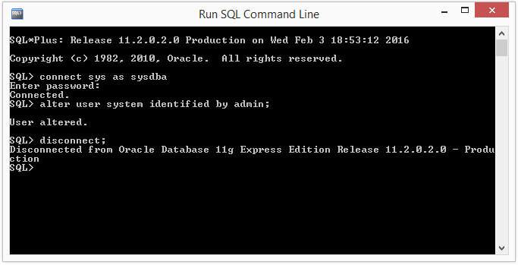

  - Now return to SQL Developer, login as system, use the commands below

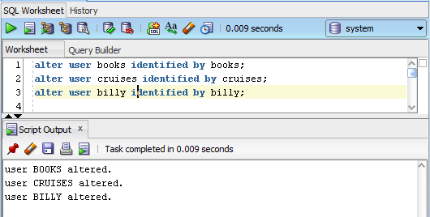

- Resetting the timeout period to unlimited
  - Once you reset all the passwords set the password timeout to UNLIMITED. Login as System and run the following command. Confirm it is set to 180 days.

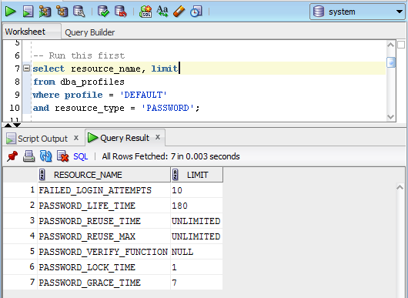

  - Now login as system and run the following commands. Confirm it is set to UNLIMITED.

